  Contemporary Outdoor-Lighting Bylaw  August 25, 2023 (version 1.0) | This document is intended to provide a starting point for developing a bylaw or ordinance that governs outdoor lighting in rural and suburban communities that have lighting zones between LZ0 and LZ2. Mid-sized or larger cities will require additional content. DarkSky International’s “Dark Sky Community” compliance will require additional regulation. It is written specifically for Massachusetts, but it can easily be adapted for use in additional states. Consider it a living document, with the intent of it being updated and modified periodically as both lighting technology and our knowledge of its impact evolves. It is adaptable in that the user may choose what is necessary for their community and what is politically possible. Think of it as regulatory buffet, utilize or modify sections as you see fit.  Note: Italicized terms are defined in Appendix A. [ ] are options and < > must be filled in by the municipality.  This version of the MA-COB was written by:  Tim Brothers (astrobrothers@gmail.com)  edited by Glenn Heinmiller and Kelly Beatty

Outdoor Lighting Bylaw for <Municipality>, Massachusetts

- Authority
This Bylaw is adopted by the <Town/City> of <Municipality> pursuant to its authority under M.G.L. Chapter 40, Section 21, as reasonable and necessary for the protection of the health and welfare of the residents of <Municipality>.

Purpose
The <City/Town> of <Municipality> hereby finds and determines that the welfare and enjoyment of <Municipality> are associated with its <rural/historic/natural> character, including its nighttime ambience. It is recognized that light pollution is a nuisance to the residents of <Municipality> as it negatively impacts human health and contributes to the loss of their night-sky heritage. Preserving and protecting the night sky through appropriate lighting practices enhances the general well-being of residents, as well as the use and enjoyment of property. Current and future outdoor-lighting systems shall be designed, constructed, installed, and maintained to:

  - Minimize light pollution resulting from the use of outdoor lighting to the greatest extent possible, especially blue light, which causes negative effects on human health, road visibility, nocturnal organisms including birds, fish, turtles, bats, pollinators and other insects, and reduces agricultural yields;
  - Protect residents from light trespass, which negatively affects the enjoyment of property and disrupts the natural circadian rhythm of humans, wildlife and agriculture;
  - Control glare to ensure safe navigation for motorists, bicyclists, and pedestrians at night, as well as increasing <Municipality>’s safety and security;
  - Minimize skyglow, to preserve <Municipality> residents’ ability to see the stars against a dark sky;
  - Provide adequate light for safe performance of outdoor tasks at night;
  - Promote efficient lighting to conserve energy, thereby reducing atmospheric carbon emissions and costs to the residents of <Municipality>.

Applicability

  - Priority of Bylaw Provisions. In case of conflict between any of the provisions of this Bylaw or any other <Municipality> regulation, the most restrictive shall apply.
  - New Lighting. All exterior lighting installed in <Municipality> after the effective date of this Bylaw shall be in conformance with the requirements established by this Bylaw and any other applicable Bylaws.
  - Existing Lighting. All outdoor luminaires that were lawfully installed prior to the effective date of this Bylaw, but that do not comply with the requirements of this Bylaw, are declared to be non-conforming. All non-conforming luminaires may continue to be used and maintained after the adoption of this Bylaw, but shall be brought into compliance with the requirements of the Bylaw upon the first to occur of any of the following:
    - A determination by the <Municipal Employee> that the luminaire constitutes a hazard to public safety or otherwise constitutes a nuisance;
    - More than fifty percent (50%) of the total square footage of a structure, as determined from the records of the Assessors and/or the <Municipal Employee>, is repaired, altered, reconstructed, or renovated;
    - With the exception of single- and two-family dwellings, if modifications or additions exceed twenty-five percent (25%) of the gross floor area, dwelling units or parking spaces, all exterior luminaires on the property shall be made to comply with the provisions of this section. For the purposes of this section, if the aggregate of any additions or modifications within the five (5) previous calendar years exceeds 25%, the provisions of this section shall apply. The requirements of this section may be reduced by special permit issued by the Planning Board upon a finding that such reduction will not detract from the objectives of this section;
    - [Change of Ownership Option] Any property that changes ownership for any reason;
    - [Source Change Option] The replacement of more than twenty-five percent (25%) of an existing system of luminaires intended to illuminate a specific area, or the replacement of an existing luminaire with a brighter one or with one that has a higher correlated color temperature;
    - [Amortization Option] All non-conforming luminaires shall be brought into conformance within <5 or 10> years of adoption of this Bylaw.

- Requirements
  - Shielding. Unless exempted elsewhere in this Bylaw, all exterior luminaires with initial lumens exceeding 600 lumens shall be fully shielded.

  - Light Output.
    - The output of any luminaire installed on a residential property shall not exceed fifteen hundred (1,500) lumens. The output of any luminaire on a nonresidential property shall not exceed five thousand (5,000) lumens, except as otherwise permitted by this Bylaw.
    - Illuminance on nonresidential properties shall not exceed the values recommended by the Illuminating Engineering Society (IES) for the specific application by more than 50% unless in the judgment of the <Municipal Employee> there are extenuating circumstances related to safety and security that justify an exception.
  - Nuisance. No exterior luminaire installed within <Municipality> shall create a lighting nuisance in the form of light trespass or glare, regardless of when it was installed.
    - Light trespass. The maximum vertical illuminance at a property line that is adjacent to a residential property or to an environmentally sensitive area shall not exceed 0.05 foot-candle. For all other adjoining property, outdoor lighting must be designed or installed so that the illuminance at the property boundary line does not exceed 0.1 foot‐candle. The measurement for compliance may be made by the <Municipal Employee> and vertical illuminance shall be measured at the property line measured five (5) feet above grade with the meter aimed toward the subject property and perpendicular to the property line. The <Municipal Employee/Board> may grant exceptions due to extenuating circumstances related to safety and security.
    - Glare. Glare is declared to be a lighting nuisance when it constitutes a hazard to public safety along a public way or causes intense discomfort to occupants of adjacent properties. This determination will be made by the <Municipal Employee> through a site visit and a visual inspection.

  - Correlated color temperature. The correlated color temperature (CCT), of the light emitted by the luminaires shall not exceed 2700 K unless introduced as part of a façade or landscape lighting scheme used exclusively for the decorative illumination through color of certain building façade, landscape features or holiday lighting. If a luminaire with a CCT of 2700 K or lower is unavailable, then a luminaire with a CCT of 3000 K may be used.
  - Outdoor accent lighting. Lighting of landscaping, monuments, plaques, flagpoles and similar installations are exempted from the shielding requirements in 4.1, but shall be focused directly at the target so that the luminaire does not create a nuisance. Such lighting shall be designed and installed so that the luminaire points downward toward the target where possible, emits no more light than is necessary for the task, and is turned off or dimmed after <a specific time> or within one (1) hour of the business or building’s closing time, whichever occurs first, unless a safety or security need is demonstrated to the <Municipal Employee/Board>.
    - String lights. Also referred to as festoon lighting. Unless fully shielded, string lights shall have an output not exceeding fifty (50) lumens per linear foot. Such lighting shall not exceed, in total, two thousand (2,000) lumens for residential properties and four thousand (4,000) lumens for nonresidential properties.
    - Landscape lighting. Illumination of landscape features and building façades shall be limited to luminaires with output not exceeding two hundred and fifty (250) lumens and shall be installed and oriented so that their light output points directly toward the feature(s) to be illuminated. Such lighting shall not exceed, in total, two thousand (2,000) lumens for residential properties and four thousand (4,000) lumens for nonresidential properties.
    - Holiday lighting. Decorative lighting used to celebrate holidays shall not be installed more than six (6) weeks prior to the holiday and shall be removed within two (2) weeks following it.
    - Flags. Any pole-mounted flag illuminated at night shall utilize no more than three (3) spotlight luminaires per flagpole. Each of these luminaires shall be installed and oriented so that their light points directly toward the flag(s), incorporate optics to create the narrowest possible beam, and not exceed six (600) lumens in output.

  - Lighting Plans. All applications for a building permit for construction that includes exterior lighting shall include lighting plans showing the location, mounting height, correlated color temperature (CCT), lumen output, BUG rating (if applicable), shielding description, and the quantity of all proposed luminaires. For non-residential property, said lighting plan must also include the proposed schedule of use, including use of timers, dimmers and/or motion-sensors. The applicant shall provide sufficient information to verify that lighting conforms to the provisions of this Bylaw. The <Municipal Employee/Board> shall have the authority to request additional information in order to confirm compliance with the provisions of this Bylaw.
  - Streetlights. This section applies to municipally-owned, municipally-installed luminaires and any other luminaires used for streetlighting along a public right of way whose total output is 2,000 lumens or greater. Each such luminaire shall conform to the following requirements:
    - The luminaire as installed must not exceed the BUG rating (as provided by the manufacturer) of B2, U0, and G2.
    - Streetlights may not be installed at heights greater than twenty-five (25) feet.
    - <Exception for decorative or period lighting Option> Exceptions may be granted by the Planning Board for installation or replacement of existing decorative or historically designed streetlighting. All other requirements of this Bylaw would still apply.
    - If <Municipality> or a utility company proposes the installation of streetlighting that involves the replacement or addition of more than ten (10) luminaires emitting at least 2000 lumens per luminaire, then the <Government Type> must seek public comment prior to installation so as to mitigate unforeseen negative impacts. Specifically, as part of the public-comment process, the project proponent must provide a demonstration installation of at least three (3) luminaire options and include at least one option with a CCT of less than 2700 K and at least one option with a BUG rating of 1/0/1.
  - Sports lighting. [Reference the most recent version of DarkSky International’s Criteria for Community-Friendly Outdoor Sports Lighting. This language may conflict with the Athletic Lighting Exemption Option below – only include one of these or they will conflict.]

Prohibitions
The use of the following types of outdoor lighting is prohibited, except as specifically exempted in this Bylaw:
  - Searchlights, sky beams, and similar lighting, except as required by public-safety personnel during emergency conditions.
  - <Optional dynamic lighting restriction> Any luminaire that dynamically varies its output by intermittently fading, flashing, blinking, or rotating. This includes strobe lighting.

Exemptions
The following are exempt from compliance with all provisions of this Bylaw, except as noted:
  - Emergency lighting, only for as long as emergency conditions so identified by public-safety personnel continue to exist. This includes the activities of law enforcement, fire and other emergency services.
  - Lighting employed during repairs of roads, utilities, and similar infrastructure, including unshielded lighting, provided that such lighting is deployed, positioned, and aimed such that to the extent possible the resulting glare and light trespass do not extend beyond the work area.
  - Any form of lighting whose use is mandated or otherwise governed by any legal jurisdiction with broader authority to that of <Municipality>.
  - Temporary lighting for events sponsored by <Municipality> or for which a license or other approval has been issued, such as concerts, fairs, and festivals.
  - [Motion Sensor Exemption Option] A motion-activated luminaire that causes a nuisance but otherwise complies with this Bylaw may be granted an exemption by <Municipal Employee/Board> as long as its output is on for no more than 10 minutes, does not flicker intermittently, and is not triggered by right-of-way traffic in any form. Owner may be granted additional time to adjust settings and position of sensor.
  - [Athletic Lighting Exemption Option, see Sports Lighting above] Athletic fields are exempt from shielding, lumen output and correlated color temperature (CCT) requirements, but are subject to all other provisions of this Bylaw. Must be turned off within one (1) hour after the end of play or by <10 PM>, whichever comes sooner.

Enforcement

  - Administrative guidance. The <Municipal Employee> is authorized to promulgate one or more interpretive documents to aid in the administration and enforcement of this Bylaw. The owner of any lot or property on which a luminaire or sign subject to this Bylaw is located or proposed to be located shall have the burden of demonstrating that the existing or proposed luminaire or sign complies with the standards established by this Bylaw. The manufacturer's specification sheet may be used to establish the lumen level of a luminaire, CCT and, if required, to verify the use of fully shielded fixture design. Illumination levels may be verified through the use of manufacturer's photometric data sheet(s) and/or photometric site drawing or through on-site calibrated light meter light level readings. The owner of any lot or property on which a luminaire or sign subject to this Bylaw is located or proposed to be located shall have the burden of demonstrating that the proposed luminaire or sign complies with the standards established by this Bylaw. A site visit at night by the <Municipal Employee> for purposes of a visual observation and/or photograph may be required to determine compliance.

  - Violations. It shall be unlawful to install or operate any outdoor lighting Luminaire in violation of any provision of this Bylaw. This Bylaw may be enforced by the <Municipal Employee>, any applicable Town board or any municipal public safety officer. If the offending luminaire is powered off or rendered inactive within 24 hours, it is no longer considered a violation.

  - Relief and Penalties. The <Municipal Employee> is authorized and empowered to institute and maintain, in the name of the <Municipality>, any and all enforcement proceedings seeking injunctive relief and any other appropriate remedy, including fines and penalties. Violation of this Bylaw shall be subject to a penalty of [$$$] if violation has not been corrected within 14 days. Each day that a violation exists shall be deemed a separate offense. This Bylaw may be enforced through the non-criminal disposition method as provided in M.G.L. c. 40D, § 21D and/or an order to cease and desist until the violation is remedied.

APPENDIX A
<MUNICIPALITY> OUTDOOR LIGHTING BYLAW DEFINITIONS AND FIGURES

DEFINITIONS

BUG rating system: A simple lighting classification system (IES TM-15-20 standard or its successor) by the Illuminating Engineering Society (IES) and the DarkSky International to describe the light pollution contributions from outdoor Luminaires, including for street and parking lot lighting. Each letter is attached to a number ranging from 0 (ideal) to 5 (unacceptable). B describes backlight that often contributes to Light trespass. U describes uplight, which contributes to skyglow, which limits a person’s ability to see the stars. G describes glare, which makes it difficult for people to see and thus makes roadways more dangerous and security lighting less effective.

Correlated Color Temperature (CCT): A specification of the color appearance of the light emitted by a light source, measured in Kelvin (K). CCT values are typically provided in lighting manufacturer data sheets. For example, high pressure sodium streetlights are approximately 2000 K and warm-white lamps are 2700 K.

Environmentally Sensitive Area: Sensitive uses include: all residential uses, any land subject to a conservation restriction, agricultural land or any land that contains threatened or endangered species habitats.

Foot-candle: A measurement of light intensity. One (1) foot-candle (fc) is defined as enough light to uniformly illuminate one square foot (1 ft²) with one (1) lumen. Lux (lx) is the SI unit of illuminance; 1 foot-candle corresponds to 10.764 lx.

Fully shielded: An outdoor luminaire constructed so that, in its installed position, all of the light emitted by the luminaire is projected below the horizontal plane that passes through the lowest light emitting part of the luminaire. See Figure 1.

Glare: Intense and blinding light emitted by a luminaire that reduces visibility and creates visual discomfort and/or momentary visual impairment.

Illuminance: Density of luminous flux (the rate of transfer of energy) incident on a surface, often measured on horizontal or vertical surfaces in foot-candles (fc or Lumens/ft²). Example, the full Moon casts 0.01 fc.

IES: Illuminating Engineering Society is a recognized authoritative body on the science and application of lighting that publishes and promotes recommended practices for a variety of specific lighting applications.

Lamp: The bulb or other light-emitting portion of a luminaire, not inclusive of any reflective or refractive optics used to direct light.

Light Pollution: an adverse and/or obtrusive effect of the use of outdoor light at night,

Light trespass: Any light emitted by a luminaire that shines beyond the property on which the luminaire is installed and increases the Illuminance as measured at the lot line in foot-candles.

Lumen: A unit of luminous flux; the flux emitted within a unit solid angle by a point source with a uniform luminous intensity of one candela (the SI unit of luminous intensity).

Luminaire: A complete lighting assembly, consisting of a lamp/bulb, housing, optic(s), and other structural elements, but not including any mounting pole or surface.

Luminance: The amount of light that passes through, is emitted, or reflected, from a particular area, and falls within a given solid angle. The SI (International System of Units) unit of luminance is candela per square meter (cd/m²), also known as a nit.

Nuisance: The unreasonable, unwarranted and/or unlawful use of property, which causes inconvenience, disruption of enjoyment, or damage to others, either to individuals and/or to the general public.

Skyglow: A measurable glow in the night sky deriving from an artificial source.

FIGURES

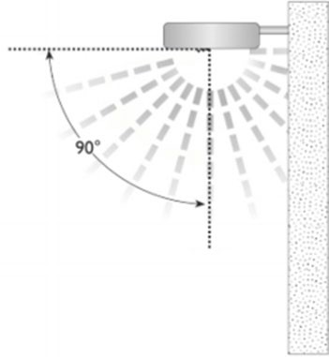
Figure 1 Fully shielded luminaire

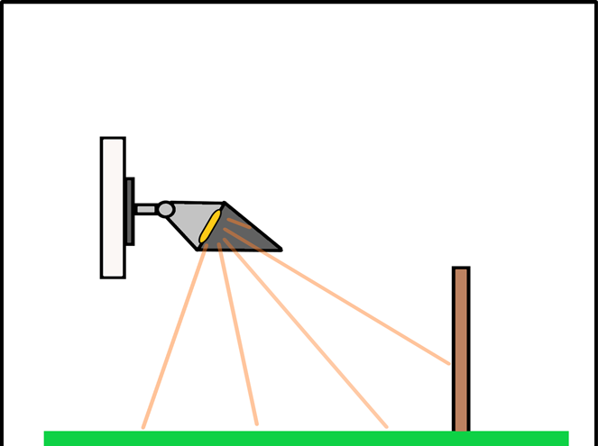
Figure 2 Fully shielded lighting that is not causing light trespass, glare or skyglow for adjacent property. In the absence of a barrier between properties, the luminaire can simply be pointed more towards the ground to satisfy the requirements of the Bylaw.

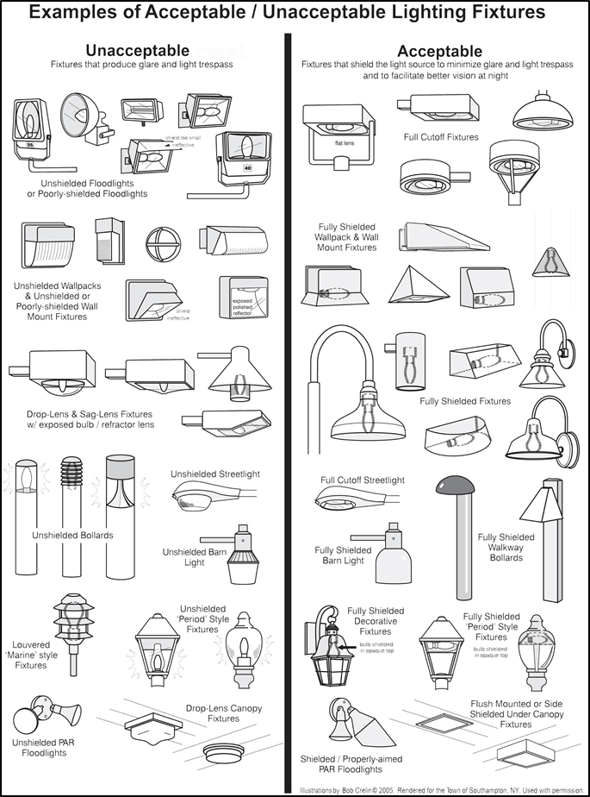
Figure 3 Examples of acceptable and unacceptable lighting fixtures or “luminaires.” The intent of this figure is to demonstrate that “acceptable” lighting eliminates or reduces glare by hiding the light emitting portion of the bulb or lamp, not that the general style of fixture is prohibited.

